IT 3850 Computer System Administration  
Spring 2022

**Laboratory # 10 - MySQL**

*Dr. Ronny Bazan (Contact: bazanantequerar@umsystem.edu)*



1. **Objectives**
   1. Install MySQL in RHEL
   2. Secure and connect to the database manager
   3. Configure remote access to MySQL server
   4. Grant and revoke user privileges
   5. Take and restore backups
2. **Material Required**

A Red Hat EC2 instance deployed in AWS, and a RHEL Linux VM.

1. **Activity**
2. Go through the MySQL Module slides and videos available on Canvas.
3. Make sure that your RHEL VM is connected to the internet.
4. Deploy an instance in AWS,
   1. In Step 1, select ‘Red Hat Enterprise Linux 8 (HVM)’ AMI.



* 1. In Step 2, select General Purpose, t2.micro.
  2. In Step 3, enable ‘Auto-assign Public IP’ in order to obtain a public IP for the instance.



* 1. Keep the default values in Steps 4 and 5.
  2. In Step 6, configure a *security group* with the following values.

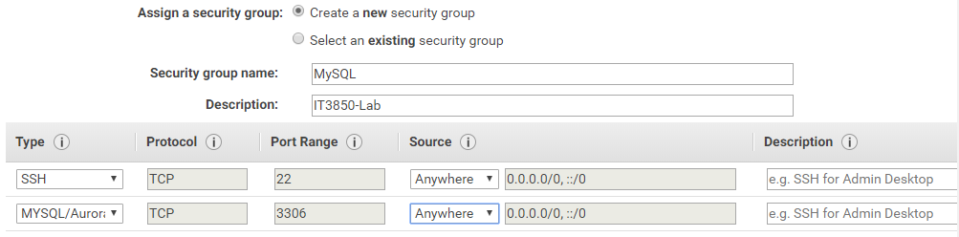

Note. The Security Group replaces the firewall in AWS. This step opens the port **3306/TCP** that corresponds to MySQL.

* 1. Before deploying the instance, make sure you have access to the *key pair* (.pem file) in order to ssh from your RHEL to the deployed instance.

Note. If your key is not located in your RHEL already, then you have 3 options. First option, install VMware tools on RHEL and then Drag and drop the key from your local system to RHEL. Second option, directly drag and drop the key to your Windows system and from there copy it to RHEL through scp, FTP or SAMBA. Third option, visit the AWS web console through RHEL; you can download a newly created .pem file directly on RHEL.

1. **Review Questions**

**\*Important*. For each question where you are required for a screenshot, include the screenshot that clearly demonstrates you completed that step successfully.** Include any commands you executed for each step as well, if applicable**. All the screenshots for this lab and future labs must include your pawprint in the command prompt or have other information visible that identifies you (i.e. type/draw your pawprint).** This is to ensure that you are submitting your own work.

Answer the following questions and perform the following tasks. Construct your report in a document to submit on Canvas. Make sure to read the directions and the rubric carefully!

1. From RHEL, ssh to the EC2 instance using its public IP address.

1. Install MySQL server on the EC2 instance.

1. Secure your MySQL server installation.

1. On your EC2 instance, connect to the MySQL server.

1. Graphical user interface, text

   Description automatically generatedUsing an SQL query, create a SQL user and name it as your pawprint. Make sure to add a password for this user. This new account will be used to connect to MySQL from remote systems.

1. Grant all privileges to the new user

1. Test the remote connection. Open another terminal in your *local* RHEL VM, execute the command ifconfig with the network interface connected to the Internet. i.e. if the network interface that allows the system to connect to the Internet is ens38, then you will need to execute ‘ifconfig ens38’. Then in the same screen show that you are able to connect successfully to MySQL installed in a AWS instance using the account you created previously.

1. On your MySQL server, create the database ‘sysadmin’ and a table named ‘operatingsystems’ with the following fields:

* 1. id (int) - **make this the primary key**
  2. os (varchar40)
  3. architecture(varchar10)

1. Text

   Description automatically generatedAdd the following values to the ‘operatingsystems’ table:

id os architecture

1 RHEL 64bits

2 RHEL 32bits

3 RedHat 64bits

4 Debian 32bits

1. Display the values of the table ‘operatingsystems’.

1. From the EC2 instance, take a backup of the ‘sysadmin’ database (name it [your_pawprint].sql), display the .sql file, and remove the ‘operatingsystems’ table.

1. Text

   Description automatically generatedRestore the database tables and values from the backup and display the content of the ‘operatingsystems’ table.